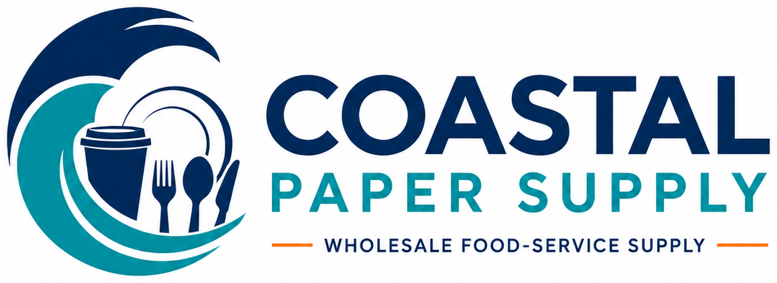
WHOLESALE FOODSERVICE CATALOG
Restaurant • Catering • Institutional Supplies
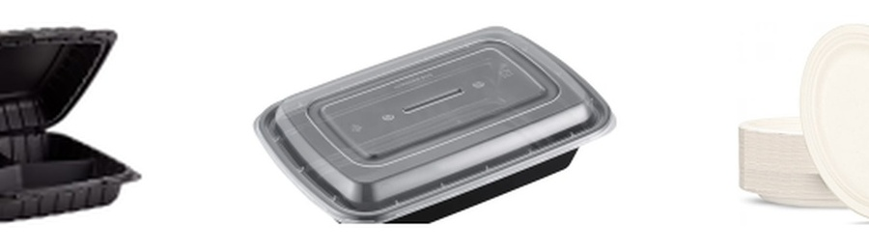
Clear case pricing • Organized product families • Local delivery available
FREE SHIPPING
Delivery available anywhere — proudly serving Hampton Roads and surrounding communities.
PHONE  757-330-2303 | EMAIL  coastalpapersupply1971@gmail.com
SERVICE AREA  Hampton Roads | ORDERING  Call or email for availability

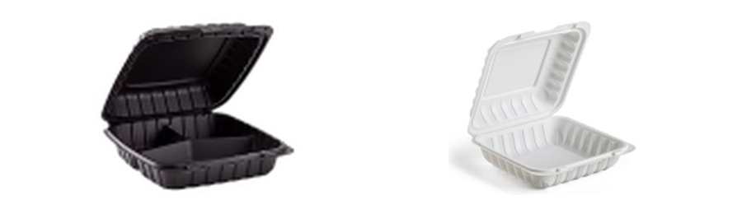 | TAKEOUT CONTAINERS  MFPP, clear OPS, and sugarcane hinged containers
MFPP HINGED CONTAINERS
ITEM / VARIATION |  | DETAILS | CASE PACK |  | PRICE
6 × 6 × 3 in. — Black — 1 Compartment  WC P66-BK |  | Standard configuration | 250 containers/case |  | $22.99  Per Case
6 × 6 × 3 in. — White — 1 Compartment  WC P66W |  | Standard configuration | 250 containers/case |  | $24.99  Per Case
8 × 8 × 3 in. — Black — 1 Compartment  WC P88-BK |  | Standard configuration | 150 containers/case |  | $25.99  Per Case
8 × 8 × 3 in. — Black — 3 Compartments  WC P83-BK |  | Standard configuration | 150 containers/case |  | $25.99  Per Case
8 × 8 × 3 in. — White — 1 Compartment  WC P88W |  | Standard configuration | 150 containers/case |  | $25.99  Per Case
8 × 8 × 3 in. — White — 3 Compartments  WC PW83 |  | Standard configuration | 150 containers/case |  | $25.99  Per Case
9 × 6 × 3 in. — Black — 1 Compartment  WC P206-BK |  | Standard configuration | 150 containers/case |  | $21.99  Per Case
9 × 6 × 3 in. — White — 1 Compartment  WC PW206 |  | Standard configuration | 150 containers/case |  | $21.99  Per Case
9 × 9 × 3 in. — Black — 1 Compartment  WC P99-BK |  | Standard configuration | 150 containers/case |  | $29.99  Per Case
9 × 9 × 3 in. — Black — 3 Compartments  WC P93-BK |  | Standard configuration | 150 containers/case |  | $33.99  Per Case
9 × 9 × 3 in. — White — 1 Compartment  WC P99W |  | Standard configuration | 150 containers/case |  | $29.99  Per Case
9 × 9 × 3 in. — White — 3 Compartments  WC PW93 |  | Standard configuration | 150 containers/case |  | $29.99  Per Case
CLEAR OPS HINGED CONTAINERS |  |  |  | 
ITEM / VARIATION |  | DETAILS | CASE PACK |  | PRICE
5 1/4 × 5 3/8 × 2 5/8 in. — Clear  WC PSC-C53 |  | Standard configuration | 500 containers/case |  | $51.99  Per Case
SUGARCANE HINGED CONTAINERS |  |  |  | 
ITEM / VARIATION |  | DETAILS | CASE PACK |  | PRICE
6 × 6 × 3 in. — White — 1 Compartment  WC HC66W |  | Standard configuration | 400 containers/case |  | $43.99  Per Case
8 × 8 × 3 in. — White — 1 Compartment  WC HC88W |  | Standard configuration | 200 containers/case |  | $39.99  Per Case
8 × 8 × 3 in. — White — 3 Compartments  WC HC88W-3C |  | Standard configuration | 200 containers/case |  | $39.99  Per Case
9 × 6 × 3 in. — White — 1 Compartment  WC HC96W |  | Standard configuration | 200 containers/case |  | $29.99  Per Case
9 × 9 × 3 in. — White — 1 Compartment  WC HC99W |  | Standard configuration | 200 containers/case |  | $37.99  Per Case
9 × 9 × 3 in. — White — 3 Compartments  WC HC99W-3C |  | Standard configuration | 200 containers/case |  | $37.99  Per Case

 | MICROWAVE CONTAINERS  Rectangular and round microwave-safe takeout containers
RECTANGULAR MICROWAVE CONTAINERS Clear lids included
ITEM / VARIATION |  | DETAILS | CASE PACK |  | PRICE
Rectangular PP Microwave Container with Clear Lid  WC CB-16B |  | 16 oz. • PP, Black base, Clear lid • 1 compartment • Lid included | 150 sets/case |  | $25.99  Per Case
Rectangular PP Microwave Container with Clear Lid  WC CB-24B |  | 24 oz. • PP, Black base, Clear lid • 1 compartment • Lid included | 150 sets/case |  | $27.50  Per Case
Rectangular PP Microwave Container with Clear Lid  WC CB-28B |  | 28 oz. • PP, Black base, Clear lid • 1 compartment • Lid included | 150 sets/case |  | $29.50  Per Case
Rectangular PP Microwave Container with Clear Lid  WC CB-33B-3C |  | 33 oz. • PP, Black base, Clear lid • 3 compartments • Lid included | 150 sets/case |  | $42.99  Per Case
Rectangular PP Microwave Container with Clear Lid  WC CB-38B |  | 38 oz. • PP, Black base, Clear lid • 1 compartment • Lid included | 150 sets/case |  | $32.50  Per Case
ROUND MICROWAVE CONTAINERS Clear lids included |  |  |  | 
ITEM / VARIATION |  | DETAILS | CASE PACK |  | PRICE
Round PP Microwave Container with Clear Lid  WC W7-24B |  | 24 oz. • PP, Black base, Clear lid • 1 compartment • Lid included | 150 sets/case |  | $24.99  Per Case
Round PP Microwave Container with Clear Lid  WC W7-32B |  | 32 oz. • PP, Black base, Clear lid • 1 compartment • Lid included | 150 sets/case |  | $26.99  Per Case
Round PP Microwave Container with Clear Lid  WC W9-48B |  | 48 oz. • PP, Black base, Clear lid • 1 compartment • Lid included | 150 sets/case |  | $43.99  Per Case

 | KRAFT CONTAINERS & BOXES  All kraft takeout containers, food boxes, and matching lids
SQUARE KRAFT CONTAINERS
ITEM / VARIATION |  | DETAILS | CASE PACK |  | PRICE
Square Kraft Food Container |  | 30 oz. • Kraft paper • Lid sold separately | 300 containers/case |  | $54.50  Per Case
Square Kraft Food Container |  | 32 oz. • Kraft paper • Lid sold separately | 300 containers/case |  | $58.99  Per Case
Square Kraft Food Container |  | 40 oz. • Kraft paper • Lid sold separately | 300 containers/case |  | $58.99  Per Case
RECTANGULAR KRAFT CONTAINERS
ITEM / VARIATION |  | DETAILS | CASE PACK |  | PRICE
Rectangular Kraft Food Container |  | 22 oz. • Kraft paper • Lid sold separately | 300 containers/case |  | $48.99  Per Case
Rectangular Kraft Food Container |  | 33 oz. • Kraft paper • Confirm lid fit | 300 containers/case |  | $52.99  Per Case
ROUND KRAFT CONTAINERS
ITEM / VARIATION |  | DETAILS | CASE PACK |  | PRICE
Round Kraft Food Container |  | 25 oz. • Kraft paper • Lid sold separately | 300 containers/case |  | $39.99  Per Case
Round Kraft Food Container |  | 33 oz. • Kraft paper • Lid sold separately | 300 containers/case |  | $39.99  Per Case
KRAFT FOOD BOXES
ITEM / VARIATION |  | DETAILS | CASE PACK |  | PRICE
Kraft Food Box #1  WC TGB-K1 |  | 4 5/8 × 3 1/2 × 2 1/2 in. • Kraft paper | 450 boxes/case |  | $49.99  Per Case
Black Food Box #8  WC TGB-K8 |  | 6 × 4 5/8 × 2 1/2 in. • Kraft paper, Black | 300 boxes/case |  | $42.99  Per Case
Kraft Food Box #2  WC TGB-K2 |  | 7 3/4 × 5 1/2 × 2 in. • Kraft paper | 200 boxes/case |  | $36.50  Per Case
Kraft Food Box #4  WC TGB-K4 |  | 7 7/8 × 5 1/2 × 3 1/2 in. • Kraft paper | 200 boxes/case |  | $39.99  Per Case
KRAFT CONTAINER LIDS Lids sold separately
ITEM / VARIATION |  | DETAILS | CASE PACK |  | PRICE
PET Lid for Rectangular Kraft Container |  | 22/32 oz. • Clear • Lid sold separately | 300 lids/case |  | $30.50  Per Case
PP Lid for Rectangular Kraft Container |  | 22/32 oz. • PP plastic • Lid sold separately | 300 lids/case |  | $28.99  Per Case
PET Lid for Round Kraft Container |  | 25/33 oz. • Clear • Lid sold separately | 300 lids/case |  | $37.50  Per Case
PP Lid for Round Kraft Container |  | 25/33 oz. • PP plastic • Lid sold separately | 300 lids/case |  | $35.99  Per Case
PET Lid for Square Kraft Container |  | Square sizes not stated • Clear • Lid sold separately | 300 lids/case |  | $52.50  Per Case
PP Lid for Square Kraft Container |  | Square sizes not stated • PP plastic • Lid sold separately | 300 lids/case |  | $41.50  Per Case

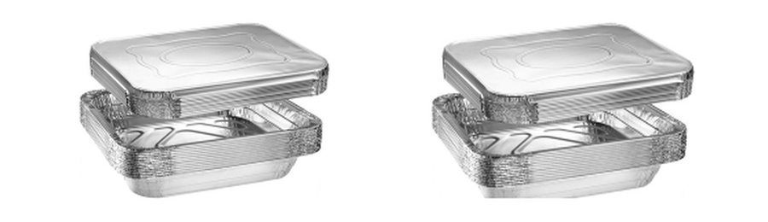 | ALUMINUM & FOIL  Aluminum pans, pan lids, foil rolls, and pop-up foil sheets
ALUMINUM PANS
ITEM / VARIATION |  | DETAILS | CASE PACK |  | PRICE
Oblong Aluminum Pan  WC 705 |  | 1 lb • Aluminum • Lid sold separately | 1,000 pans/case |  | $74.99  Per Case
Oblong Aluminum Pan — Deep |  | 1.5 lb • Aluminum • Confirm lid fit | 500 pans/case |  | $58.99  Per Case
Oblong Aluminum Pan  WC 788 |  | 2.25 lb • Aluminum • Lid sold separately | 500 pans/case |  | $74.99  Per Case
Round Aluminum Pan  WC AP07 |  | 7 in. • Aluminum • Lid sold separately | 500 pans/case |  | $56.50  Per Case
Round Aluminum Pan  WC AP08 |  | 8 in. • Aluminum • Lid sold separately | 500 pans/case |  | $67.99  Per Case
Steam Table Aluminum Pan — Deep  WC HST-D |  | Half Size Deep • Aluminum • Lid sold separately | 100 pans/case |  | $35.99  Per Case
Steam Table Aluminum Pan — Deep  WC FST-D |  | Full Size Deep • Aluminum • Lid sold separately | 50 pans/case |  | $58.99  Per Case
Steam Table Aluminum Pan — Deep Heavy-Duty |  | Full Size Deep • Aluminum • Lid sold separately | 50 pans/case |  | $64.99  Per Case
Steam Table Aluminum Pan — Medium  WC HST-M |  | Half Size Medium • Aluminum • Lid sold separately | 100 pans/case |  | $44.99  Per Case
Steam Table Aluminum Pan — Medium |  | Full Size Medium • Aluminum • Lid sold separately | 50 pans/case |  | $60.50  Per Case
Steam Table Aluminum Pan — Shallow  WC HST-S |  | Half Size Shallow • Aluminum • Lid sold separately | 100 pans/case |  | $44.99  Per Case
Steam Table Aluminum Pan — Shallow  WC FST-S |  | Full Size Shallow • Aluminum • Lid sold separately | 50 pans/case |  | $59.99  Per Case
ALUMINUM PAN LIDS Lids sold separately unless noted |  |  |  | 
ITEM / VARIATION |  | DETAILS | CASE PACK |  | PRICE
Foil Board Oblong Pan Lid  WC FBL23 |  | 1 lb • Aluminum • Lid sold separately | 1,000 lids/case |  | $20.99  Per Case
Plastic Oblong Pan Lid  WC PL23 |  | 1.0 lb • Aluminum, Clear • Lid sold separately | 1,000 lids/case |  | $20.99  Per Case
Plastic Oblong Pan Lid  WC PL25 |  | 1.5/2.25 lb • Aluminum, Clear • Lid sold separately | 500 lids/case |  | $21.99  Per Case
Foil Board Round Pan Lid  WC FBL07 |  | 7 in. • Aluminum • Lid sold separately | 500 lids/case |  | $16.99  Per Case
Foil Board Round Pan Lid  WC FBL08 |  | 8 in. • Aluminum • Lid sold separately | 500 lids/case |  | $19.99  Per Case
Plastic Round Pan Lid  WC PL08 |  | 8 in. • Plastic, Clear • Lid sold separately | 500 lids/case |  | $20.99  Per Case
Foil Board Round Pan Lid  WC FBL09 |  | 9 in. • Aluminum • Confirm lid fit | 500 lids/case |  | $21.99  Per Case
Aluminum Steam Table Pan Lid  WC HAL100 |  | Half Size • Aluminum • Lid sold separately | 100 lids/case |  | $24.99  Per Case
Aluminum Steam Table Pan Lid  WC FAL50 |  | Full Size • Aluminum • Lid sold separately | 50 lids/case |  | $31.99  Per Case
FOIL ROLLS |  |  |  | 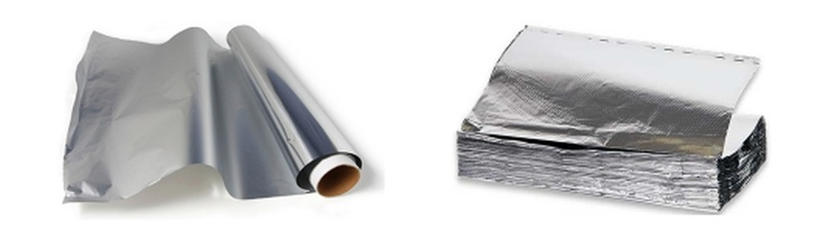
ITEM / VARIATION |  | DETAILS | CASE PACK |  | PRICE
Standard Aluminum Foil Roll  WC NY-1210ST |  | 12 in. • Aluminum | 1 rolls/case |  | $30.99  Per Case
Heavy-Duty Aluminum Foil Roll  WC NY-1850HD |  | 18 in. • Aluminum | 1 rolls/case |  | $35.99  Per Case
FOIL SHEETS
ITEM / VARIATION |  | DETAILS | CASE PACK |  | PRICE
Pop-Up Aluminum Foil Sheets  WC PUS12200 |  | 12 × 10.75 in. • Aluminum | 2,400 sheets/case |  | $91.99  Per Case

CLEAR COLD CUPS & LIDS
Clear PET cold cups with separately sold flat and dome lids
CLEAR COLD CUPS Lids sold separately
ITEM / VARIATION | DETAILS | CASE PACK | PRICE
9 oz. — Clear | Confirm lid fit | 1,000 cups/case | $43.99  Per Case
12 oz. (92 mm) — Clear | Lid sold separately | 1,000 cups/case | $48.99  Per Case
12 oz. (98 mm) — Clear | Confirm lid fit | 1,000 cups/case | $48.99  Per Case
16 oz. — Clear | Lid sold separately | 1,000 cups/case | $52.99  Per Case
20 oz. — Clear | Lid sold separately | 1,000 cups/case | $64.99  Per Case
32 oz. — Clear | Lid sold separately | 500 cups/case | $67.99  Per Case
CLEAR CUP LIDS Confirm rim size where noted
ITEM / VARIATION | DETAILS | CASE PACK | PRICE
Flat Straw-Slot PET Cup Lid | 12–24 oz. • Clear • Confirm lid fit | 1,000 lids/case | $42.99  Per Case
Dome PET Cup Lid | 16–24 oz. • Clear • Lid sold separately | 1,000 lids/case | $30.99  Per Case
Clear PET Cup Lid | 32 oz. • Clear • Lid sold separately | 500 lids/case | $32.99  Per Case
Flat Straw-Slot PET Cup Lid | 92 mm • Clear • Lid sold separately | 1,000 lids/case | $50.99  Per Case

HOT PAPER CUPS & LIDS
Hot paper cups with black and white lid options
HOT PAPER CUPS Lids sold separately
ITEM / VARIATION | DETAILS | CASE PACK | PRICE
8 oz. — Paper, Design | Confirm lid fit | 1,000 cups/case | $34.99  Per Case
10 oz. — Paper, Brown | Lid sold separately | 1,000 cups/case | $37.99  Per Case
10 oz. — Paper, Design | Lid sold separately | 1,000 cups/case | $37.99  Per Case
12 oz. — Paper, Brown | Lid sold separately | 1,000 cups/case | $41.99  Per Case
12 oz. — Paper, Design | Lid sold separately | 1,000 cups/case | $41.99  Per Case
12 oz. — Paper, White | Lid sold separately | 1,000 cups/case | $41.99  Per Case
16 oz. — Paper, Brown | Lid sold separately | 1,000 cups/case | $48.99  Per Case
16 oz. — Paper, Design | Lid sold separately | 1,000 cups/case | $48.99  Per Case
16 oz. — Paper, White | Lid sold separately | 1,000 cups/case | $48.99  Per Case
HOT CUP LIDS Lids sold separately
ITEM / VARIATION | DETAILS | CASE PACK | PRICE
Standard Hot Cup Lid | 10–24 oz. • Plastic — color not stated • Lid sold separately | 1,000 lids/case | $27.99  Per Case
Dome Hot Cup Lid — Black | 10–24 oz. • Plastic, Black • Lid sold separately | 1,000 lids/case | $30.99  Per Case
Dome Hot Cup Lid — White | 10–24 oz. • Plastic, White • Lid sold separately | 1,000 lids/case | $28.99  Per Case

PORTION CUPS & LIDS
Clear portion cups and matching lids
PORTION CUPS Lids sold separately
ITEM / VARIATION | DETAILS | CASE PACK | PRICE
1 oz. — Clear | Material not confirmed • Lid sold separately | 2,500 cups/case | $18.99  Per Case
2 oz. — Black | Material not confirmed • Lid sold separately | 2,500 cups/case | $24.99  Per Case
2 oz. — Clear | Material not confirmed • Lid sold separately | 2,500 cups/case | $25.99  Per Case
3.25 oz. — Clear | Material not confirmed • Confirm lid fit | 2,500 cups/case | $45.99  Per Case
4 oz. — Clear | Material not confirmed • Lid sold separately | 2,500 cups/case | $47.99  Per Case
PORTION CUP LIDS Lids sold separately
ITEM / VARIATION | DETAILS | CASE PACK | PRICE
Portion Cup Lid | 1 oz. • Clear • Material not confirmed • Lid sold separately | 2,500 lids/case | $15.99  Per Case
Portion Cup Lid | 2 oz. • Clear • Material not confirmed • Lid sold separately | 2,500 lids/case | $21.99  Per Case
Portion Cup Lid | 4 oz. • Clear • Material not confirmed • Lid sold separately | 2,500 lids/case | $38.99  Per Case

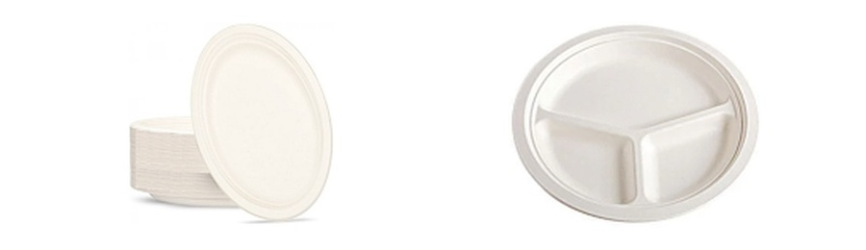 | PLATES & BOWLS  Plastic and sugarcane plates, bowls, and bowl lids
PLASTIC PLATES
ITEM / VARIATION |  | DETAILS | CASE PACK |  | PRICE
Plastic Plate |  | 7 in. • Plastic, Black | 1,000 plates/case |  | $60.99  Per Case
Plastic Plate |  | 9 in. • Plastic, White | 400 plates/case |  | $35.99  Per Case
SUGARCANE PLATES
ITEM / VARIATION |  | DETAILS | CASE PACK |  | PRICE
Round Sugarcane Plate  WC RP06W |  | 6 in. • White | 1,000 plates/case |  | $32.50  Per Case
Oval Sugarcane Plate  WC RP7510W |  | 7.5 × 10 in. • White | 500 plates/case |  | $58.99  Per Case
Round Sugarcane Plate  WC RP09W-3C |  | 9 in. • White • 3 compartments | 500 plates/case |  | $38.99  Per Case
Round Sugarcane Plate  WC RP10W-3C |  | 10 in. • White • 3 compartments | 500 plates/case |  | $49.99  Per Case
SUGARCANE BOWLS Dome lids sold separately
ITEM / VARIATION |  | DETAILS | CASE PACK |  | PRICE
Round Sugarcane Bowl  WC BB24 |  | 24 oz. • Natural • Lid sold separately | 400 bowls/case |  | $51.50  Per Case
Round Sugarcane Bowl  WC BB32 |  | 32 oz. • Natural • Lid sold separately | 400 bowls/case |  | $68.99  Per Case
SUGARCANE BOWL LIDS Lids sold separately
ITEM / VARIATION |  | DETAILS | CASE PACK |  | PRICE
PET Dome Lid for Sugarcane Bowl  WC BBDL |  | 24/32/40 oz. • Clear • Lid sold separately | 400 lids/case |  | $60.99  Per Case

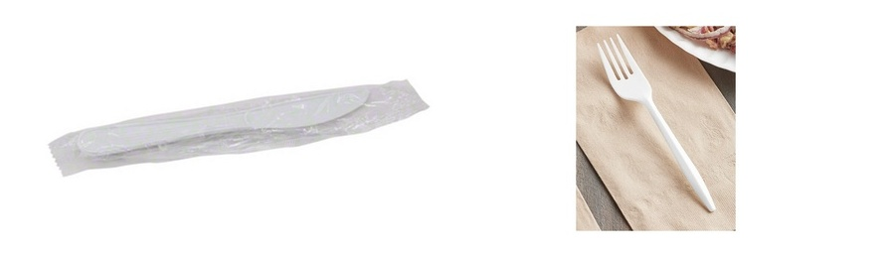 | CUTLERY & CUTLERY KITS  Black and white heavy-weight cutlery
BLACK HEAVY-WEIGHT CUTLERY
ITEM / VARIATION |  | DETAILS | CASE PACK |  | PRICE
Heavy-Weight Black Fork — Bulk  WC FK305BK |  | PP, Heavy-weight, Black | 1,000 pieces/case |  | $18.99  Per Case
Heavy-Weight Black Fork — Individually Wrapped  WC FK405BK |  | PP, Heavy-weight, Black | 1,000 pieces/case |  | $23.99  Per Case
Heavy-Weight Black Knife — Bulk  WC KE305BK |  | PP, Heavy-weight, Black | 1,000 pieces/case |  | $18.99  Per Case
Heavy-Weight Black Knife — Individually Wrapped  WC KE405BK |  | PP, Heavy-weight, Black | 1,000 pieces/case |  | $22.99  Per Case
Heavy-Weight Black Soup Spoon — Bulk  WC SP305BK |  | PP, Heavy-weight, Black | 1,000 pieces/case |  | $19.99  Per Case
Heavy-Weight Black Soup Spoon — Individually Wrapped  WC SP405BK |  | PP, Heavy-weight, Black | 1,000 pieces/case |  | $23.99  Per Case
Heavy-Weight Black Teaspoon — Bulk  WC TP305BK |  | PP, Heavy-weight, Black | 1,000 pieces/case |  | $19.99  Per Case
Heavy-Weight Black Teaspoon — Individually Wrapped  WC TP405BK |  | PP, Heavy-weight, Black | 1,000 pieces/case |  | $24.99  Per Case
WHITE HEAVY-WEIGHT CUTLERY
ITEM / VARIATION |  | DETAILS | CASE PACK |  | PRICE
Heavy-Weight White Fork — Bulk  WC FK305W |  | PP, Heavy-weight, White | 1,000 pieces/case |  | $18.99  Per Case
Heavy-Weight White Fork — Individually Wrapped  WC FK405W |  | PP, Heavy-weight, White | 1,000 pieces/case |  | $23.99  Per Case
Heavy-Weight White Knife — Bulk  WC KE305W |  | PP, Heavy-weight, White | 1,000 pieces/case |  | $18.99  Per Case
Heavy-Weight White Knife — Individually Wrapped  WC KE405W |  | PP, Heavy-weight, White | 1,000 pieces/case |  | $22.99  Per Case
Heavy-Weight White Soup Spoon — Bulk  WC SP305W |  | PP, Heavy-weight, White | 1,000 pieces/case |  | $19.99  Per Case
Heavy-Weight White Soup Spoon — Individually Wrapped  WC SP405W |  | PP, Heavy-weight, White | 1,000 pieces/case |  | $23.99  Per Case
Heavy-Weight White Teaspoon — Bulk  WC TP305W |  | PP, Heavy-weight, White | 1,000 pieces/case |  | $19.99  Per Case
Heavy-Weight White Teaspoon — Individually Wrapped  WC TP405W |  | PP, Heavy-weight, White | 1,000 pieces/case |  | $24.99  Per Case

CUTLERY & CUTLERY KITS
Medium-weight and clear cutlery with packaged utensil kits
MEDIUM-WEIGHT WHITE CUTLERY
ITEM / VARIATION |  | DETAILS | CASE PACK |  | PRICE
Medium-Weight White Fork — Bulk  WC FK10W |  | PP, Medium-weight, White | 1,000 pieces/case |  | $7.99  Per Case
Medium-Weight White Fork — Individually Wrapped  WC FK20W |  | PP, Medium-weight, White | 1,000 pieces/case |  | $17.99  Per Case
Medium-Weight White Knife — Bulk  WC KN10W |  | PP, Medium-weight, White | 1,000 pieces/case |  | $7.99  Per Case
Medium-Weight White Knife — Individually Wrapped  WC KE20W |  | PP, Medium-weight, White | 1,000 pieces/case |  | $16.99  Per Case
Medium-Weight White Soup Spoon — Bulk  WC SP10W |  | PP, Medium-weight, White | 1,000 pieces/case |  | $8.99  Per Case
Medium-Weight White Soup Spoon — Individually Wrapped  WC SP20W |  | PP, Medium-weight, White | 1,000 pieces/case |  | $16.99  Per Case
Medium-Weight White Teaspoon — Bulk  WC TP10W |  | PP, Medium-weight, White | 1,000 pieces/case |  | $8.99  Per Case
Medium-Weight White Teaspoon — Individually Wrapped  WC TP20W |  | PP, Medium-weight, White | 1,000 pieces/case |  | $14.99  Per Case
CLEAR HEAVY-WEIGHT CUTLERY
ITEM / VARIATION |  | DETAILS | CASE PACK |  | PRICE
Heavy-Weight Clear Fork — Bulk |  | Heavy-weight, Clear | 1,000 pieces/case |  | $23.99  Per Case
CUTLERY KITS |  |  |  | 
ITEM / VARIATION |  | DETAILS | CASE PACK |  | PRICE
Heavy-Weight PP Fork & Knife Salt & Pepper, 1-ply 8 × 10 in. napkin — Black  WC 5KHPBK |  | PP, Heavy-weight, Black | 250 kits/case |  | $21.99  Per Case
Heavy-Weight PP Fork, Knife & Teaspoon, 1-ply 8 × 10 in. napkin — Black  WC 4KHPBK |  | PP, Heavy-weight, Black | 250 kits/case |  | $21.99  Per Case
Heavy-Weight PP Fork, Knife & Teaspoon, Salt & Pepper, 1-ply 8 × 10 in. napkin — Black  WC 6KHPBK |  | PP, Heavy-weight, Black | 250 kits/case |  | $21.99  Per Case
Heavy-Weight PP Fork & Knife Salt & Pepper, 1-ply 8 × 10 in. napkin — White  WC 5KHPW |  | PP, Heavy-weight, White | 250 kits/case |  | $19.99  Per Case
Heavy-Weight PP Fork, Knife & Teaspoon, 1-ply 8 × 10 in. napkin — White  WC 4KHPW |  | PP, Heavy-weight, White | 250 kits/case |  | $21.99  Per Case
Heavy-Weight PP Fork, Knife & Teaspoon, Salt & Pepper, 1-ply 8 × 10 in. napkin — White  WC 6KHPW |  | PP, Heavy-weight, White | 250 kits/case |  | $21.99  Per Case
Medium-Weight PP Fork, Knife & Napkin, Salt & Pepper — White  WC 5KMW |  | PP, Medium-weight, White | 250 kits/case |  | $19.99  Per Case
Medium-Weight PP Fork, Knife & Soup Spoon, 1-ply 8 × 10 in. napkin — White  WC 4K-500 |  | PP, Medium-weight, White | 350 kits/case |  | $17.99  Per Case
Medium-Weight PP Fork, Knife & Teaspoon, Salt & Pepper, 1-ply 8 × 10 in. napkin — White  WC 6KMW |  | PP, Medium-weight, White | 250 kits/case |  | $17.99  Per Case
READY TO PLACE AN ORDER?
Call 757-330-2303 or email coastalpapersupply1971@gmail.com for availability, quotes, and delivery scheduling.
FREE SHIPPING • HAMPTON ROADS SERVICE AREA

